
BeOne 3Q 2025 Earnings Call | Ph 3 trial (Z+S vs. A+V) in 1L CLL planned in 1H 2026; Brukinsa revenue +51% YoY ($1.0B)

Company: BeOne  Drug: Brukinsa (Zanubrutinib, BTKi); Sonrotoclax (BCL2i);  BGB-16673 (catadegbrutinib; BTK degrader) | Date: Nov 6th, 2025  Source(s): Press Release, Presentation, Webcast
What happened:
- Brukinsa generated total global revenue of $1.0 B in 3Q 2025 (+51% YoY and +10% QoQ); sustained BTKi leadership for Brukinsa in the US and now globally (overtaking Imbruvica and Calquence in 3Q as the global leader)
- 1L CLL: Plans to initiate H2H Ph 3 BGB-11417-304 trial evaluating zanubrutinib + sonrotoclax (Z+S) vs. venetoclax + acalabrutinib (V+A) in 1H 2026 to establish Z+S as the “best oral combo FD regimen” (new guidance)
  - The trial is currently not listed on any trial registry, and it is unclear what the primary endpoint of the study is at this time
- R/R CLL: Data readout from potentially pivotal Ph 2 CaDAnCe-101 (BGB-16673, N=614) study expected in 1H 2026 (reiterated)
  - Also highlighted plans for Ph 3 study evaluating fixed duration sonro + BGB-16673 in R/R CLL (new guidance)
    - Fixed duration combinations – BGB-16673 + sonrotoclax, currently in a Ph 1/2 basket study, is progressing with the goal to initiate a Phase 3 in R/R CLL based off the Ph 1/2 study, leveraging complementary MoAs to drive deep responses and timelimited therapy
- 1L MCL: PFS interim analysis from Ph 3 MANGROVE (zanubrutinib + rituximab, N=510) study is expected in 1H 2026 (updated guidance; previously 2H 2025) due to slower event accrual
- R/R MCL: Data readout and potential global submission (accelerated approval, BTD) in 4Q 2025 based on Ph 1/2 BGB-11417-201 (Sonro mono, N=125) data (reiterated)

Impact (CI PoV):
- HIGH - Brukinsa’s strong growth trajectory continues, now establishing it as the global leader (value share) in a growing BTK market. With Ph 3 CELESTIAL TN-CLL underway, BeOne has adopted an aggressive strategy, planning a Ph 3 H2H trial of Z+ S vs. V + A in 1H 2026 to position Z+S as the best oral combo FD regimen

Why it matters:
- Building on Brukinsa leadership (continuous therapy), BeOne is shifting towards internal pipeline-driven growth, with plans to address both continuous and fixed-duration treatment

Tell me more:

Financial Highlights
- In 3Q 2025, BeOne WW revenue reached $1.41 B with growth of +41% YoY driven by growth in Brukinsa sales in the US and Europe; strong underlying demand growth while maximizing value share
- Brukinsa is the US revenue leader and fastest growing brand with sales of $738.7 M in 3Q 2025, representing +47% YoY growth
- BeOne raised FY 2025 revenue guidance at $5.1 – 5.3 B driven by US Brukinsa leadership expansion and increasing global growth in EU/ROW (also noted expected impact of seasonality with BTKis in 1Q 2026)

USD | Overall
3Q 2025 | Global  $1.41 B  (41%) YoY  (8%) QoQ | US  $754.8 M  (49%) YoY  (9%) QoQ
EU
$166.5 M
(70%) YoY
(9%) QoQ
3Q 2024 | Global  $1.00 B | US  $505.4 M
EU
$98.2 M
2Q 2025 | Global  $1.31 B | US  $694.4 M
EU
$152.3 M

USD | Brukinsa Sales
3Q 2025 | Global  $1.0 B  (51%) YoY  (10%) QoQ | US  $738.7 M  (47%) YoY  (8%) QoQ
EU
$163.2 M
(68%) YoY
(8%) QoQ
3Q 2024 | Global  $690.3 M | US  $503.7 M
EU
$97.3 M
2Q 2025 | Global  $949.8 M | US  $683.7 M
EU
$150.5 M
*The financial highlights are from "BeOne 3Q 2025 IR call" document

CLL and MCL Portfolio (CI Insights in blue italics)

Brukinsa (zanubruitnib) – cBTK inhibitor
- Sustained growth momentum for Brukinsa, with recent ASH data reinforcing its competitive positioning against AMPLIFY and other Ven regimens
  - Brukinsa continues to build momentum against in-class competition, with further traction expected following the US launch of new 160 mg film-coated tablet (approved in both the US and EU)
  - BeOne aims to further strengthen SOV with 47 abstracts at ASH, reinforcing its leadership in B-cell malignancies, consistent with its strong presence at ASCO and EHA. Key abstracts include:
    - 3-year results from SEQUOIA Arm D (7094)
      - Compelling benefit in high-risk patients (PFS of 87% at 42 months) highlighted by inclusion of Z + V in NCCN guidelines as preferred treatment
    - 6-year follow-up from the ALPINE study LTE (10399)
    - SEQUOIA Arm C 1L CLL (high-risk)
    - 6-year follow-up from the SEQUOIA Arm A/B (7205)
      - BeOne touted that “double-digit better than other single-agent BTK inhibitors at that time point (6-yr follow up) and comparable to three-year fixed-duration BTKi-Venetoclax data”
      - Also, noted “while long-term follow-up data are lacking for many CLL trials (such as AMPLIFY), Brukinsa provides the robust, durable PFS that patients and physicians expect”
- Ph 3 MANGROVE (1L MCL) data readout delayed, with approval now expected in 2027
  - With slower event accrual, data readout now expected in 1H 2026 (previously 2H 2025) with US/EU approval now expected in 1Q 2027

Sonrotoclax (BGB-11417) – BCL2 inhibitor
- BeOne advancing an aggressive strategy with new H2H vs. V+A in 1L CLL to establish Z+ S as the leading oral fixed-duration option
  - With Ph 3 CELESTIAL-TNCLL trial underway and 15-month MRD data expected in 1H 2026, BeOne is now doubling down with another H2H study vs. V + A expected to be initiated in 1H 2026
    - “In that particular study, it would take a little bit of time to get into the PFS readout, and at the same time we’re also monitoring the uMRD rate which we can probably take an earlier look at.”
  - BeOne discussed the rationale for the Ph 3 Z+S vs A+V study - “We felt this is important to establish ZS as really the best oral fixed duration regimen. So we picked the one which likely will be approved as soon by the FDA, the AV regimen...”
- BeOne aims to increase SOV at ASH and set the narrative for Z+S ahead of AMPLIFY approval in 1H 2026
  - BeOne is strategically showcasing the robust combination data for sonrotoclax (S+O, Z+S, Z+S+O) from multiple cohorts of Ph 1/1b BGB-11417-101 at ASH 2025; this builds a compelling clinical foundation
    - Fixed-duration combinations show exceptional depth as zanubrutinib plus sonrotoclax achieved 92% uMRD4 at 12 months in treatment-naïve CLL
    - The company stressed about the "exceptionally quick" kinetics, with a median time to uMRD of only ~4 months” (uMRD data was best uMRD and not the iwCLL guided definition as seen in the Ph 3 AMPLIFY study; ASH abs: 4617)
  - BeOne underscored sonrotoclax's best-in-class potential by drawing favorable indirect comparisons to venetoclax
  - BeOne reiterated prior messaging of Sonro as a potential best-in-class BCL2 inhibitor, offering superior potency, selectivity, and convenience versus Ven, with an optimized ramp-up schedule expected to require only a single clinic visit for >90% of patients
- R/R CLL: Reiterated filing in China (priority review) based on Ph 2 BGB-11417-202 (Sonro mono, N=100) with approval guided for 1H 2026
- R/R MCL approval (CI estimates global approval in 2Q 2026) expected to drive halo effect in CLL and also pave the way for potential NCCN guideline inclusion in CLL (uMRD, Ph 3 CELESTIAL-TNCLL)
  - No timeline updates were provided regarding the MRD data expected in 1H 2026 from Ph 3 CELESTIAL-TNCLL trial (CI estimates approval in 4Q 2028)
  - Reiterated acceptance of submission in China (priority review) based on the Ph 2 study with approval guided for 1H 2026

Catadegbrutinib (BGB-16673) - BTK degrader
- No change in timelines noted for US filing of catadegbrutinib in R/R CLL
  - Following data readout (ORR and DoR) from single-arm Ph 2 CaDAnCe-101 trial (R/R CLL, BGB-16673, N=621; Continuous use) in 2026, accelerated US approval can now be expected in 1Q 2027 in R/R CLL
  - EU approval: TBD; EMA may not accept single-arm studies in R/R CLL
  - Also, BeOne will be presenting updated data at ASH 2025 from Ph 1/2 CaDAnCe-101 study
- With first patients being dosed in pivotal Ph 3 trials in R/R CLL, catadegbrutinib continues to make progress, with potential to become first-in-class, orally available BTK degrader

Q&A Highlights:
Brukinsa
- BeOne highlighted strong Brukinsa growth in Europe despite the launch post-AMPLIFY
  - “In Europe we grew tremendously so close to 70% and we notified in Europe is some country like Germany, Austria, AMPLIFY launched and we don't see much excitement among the HCPs and the company made active switch the mono Acala to AMPLIFY, but so far we have not seen - we see some prescription but not extremely large prescription. And therefore the total Acala in Europe, if you see the number is flattening..”

Relevant Slides:
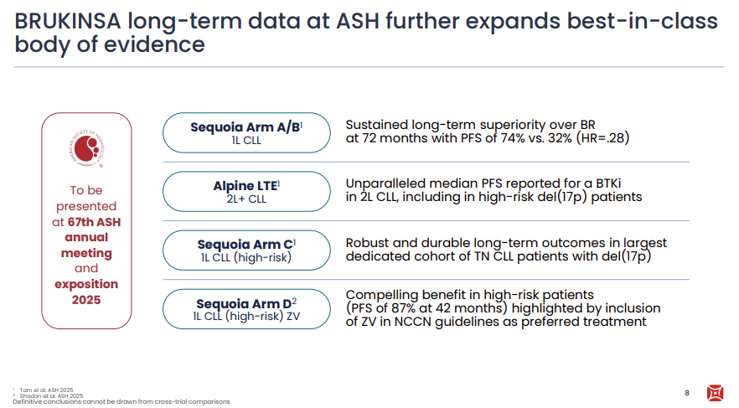

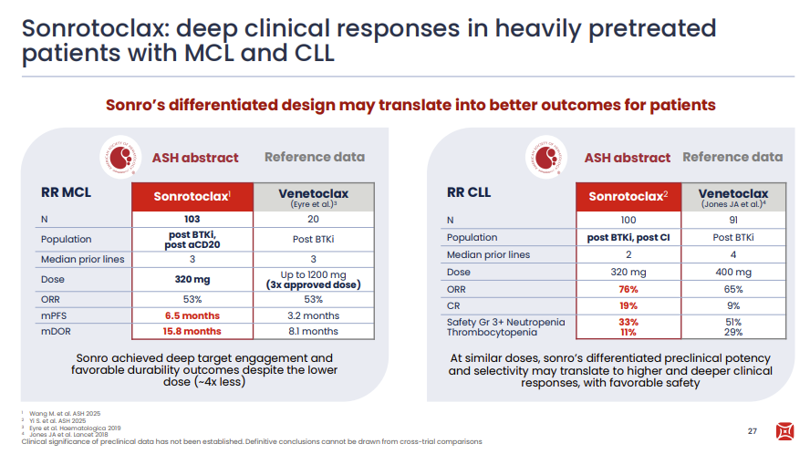
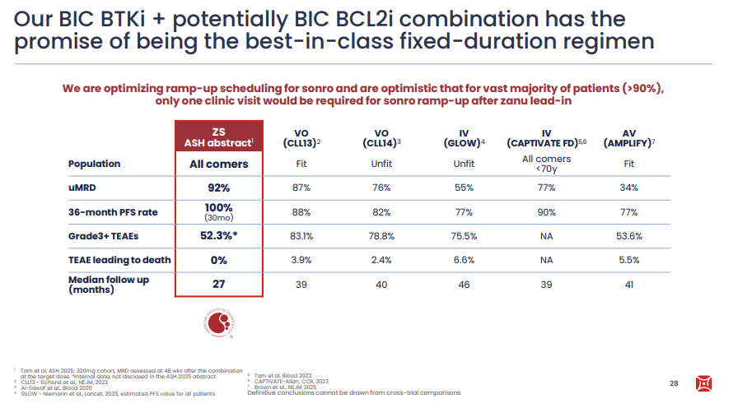

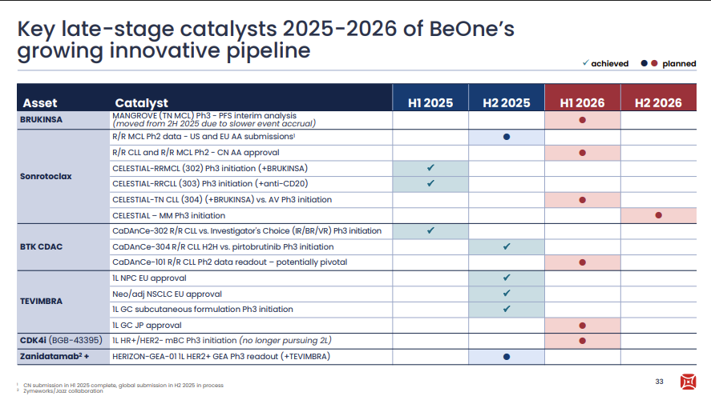

For questions, please reach out to:
International / Affiliates: Harjit Bajwa
US: Richa Sharma
Corporate Strategy, R&D and PCS: Claudia Lanauze Torres
Invite your colleagues to CI Edge | Manage Email Preferences | Unsubscribe

This document/email contains competitive intelligence collected via an approved competitive intelligence supplier working on behalf of AbbVie. We collect competitive intelligence consistent with industry standards and AbbVie policy. Not for field distribution. Please reach out to APEX/IMABI, Legal, or OEC teams with any questions.

